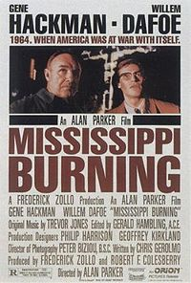
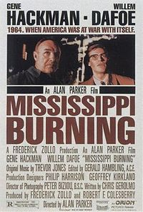
Theatrical poster by Bill Gold
Directed by Alan Parker
Produced by Robert F. Colesberry
Frederick Zollo Written by Chris Gerolmo
Frederick Zollo Starring Gene Hackman
Willem Dafoe
Brad Dourif
Frances McDormand Music by Trevor Jones Cinematography Peter Biziou Editing by Gerry Hambling Distributed by Orion Pictures Release date(s) December 9, 1988 Running time 128 minutes Country United States Language English

